

LEARNERS WITH SEVERE TO PROFOUND INTELLECTUAL DISABILITY
LESSON PLAN YEAR 2
TERM 1 & 2

CONTENT
- Lesson plan theme and topics……………………………………………………………………………….….……. Pg 2
- Assessment methods and descriptors……………………………………………………………………….………. Pg 3
- Carer’s role in the facilitation of the lesson plan theme and topic………………………………………….……...Pg 4
- General accommodations……………………………………………………………………………………….……..Pg 10
- Addendums……………………………………………………………………………………………………….……..Pg 12

Theme: Me and my environment Topic: Me and my home |  |  | Start date: January 2024 Date completed: June 2024
Note: Be mindful that learners come from different homes and different cultural backgrounds. All these homes and households should be acknowledged, appreciated, and given the same value and respect during the lesson. The language, both verbal and nonverbal used when discussing these different homes should be handled with positivity, respect and appreciation.  The LSPID team members, together with the special care centre staff, are responsible for adapting lesson plan activities, LTSM and other resources to suit the cultural environment of the area the special care centre is located in.  Throughout the day, observe the learner's reaction to the different activities and try to find time to record learner’s reactions using an informal observation sheet.  Your centres’ daily programme may not follow the same sequential progression as this lesson plan. There is no need to follow this plan as is. Use the lesson content and follow the daily programme you use in your centre/ school.  The therapists and teachers among the outreach team members will guide and support the caregivers / teachers in planning and implementing the lesson activities. This includes assessing learners and guiding caregivers and teachers on relevant accommodation of learners, should some learners’ impairments impede their participation in the learning programme. |  |  | Resources:  Learning and teaching support materials that are mentioned in the lesson plan include, but are not limited, to the ones listed below:  Recyclable material  Cereal boxes, bottle caps, match boxes, toilet rolls, newspaper, magazines, sticks, paper towel rolls  Art material  Wool, string, buttons, pipe cleaners, play dough, paint, glue, wax crayons, ice cream sticks, pieces of off-cut material, paper plates, chalk, tape  Photos or DVDs (DVDs not compulsory)  Media of the outside structure and inside areas of different homes, e.g areas where the cooking, washing, eating, bathing and sleeping takes place.  LSPID teams need to supply resources that are cultural specific to the area that they support, taking into account learners’ different circumstances. .
Assessment
Method of assessment: Informal assessments, observations & carer interviews
Assessment tool: Checklists, observation sheets & lesson plan assessments recording tools (LARTS)
PLEASE NOTE: Descriptors below serve as the learner participation requirements during all parts of the daily programme, e.g., fine motor, morning ring.
Functioning groups | Awareness | Transitional |  | Interactive
Language (LC) | Learner outcomes: | Learner outcomes: |  | Learner outcomes:
Rec | - React (or react intermittingly) to familiar people and events. | - Respond consistently to familiar people and events. |  | - Initiate interactions with familiar people.  - Actively explore events for more extended periods.
Expr
Pre lit
Life-Skills (LS) | Learner outcomes: | Learner outcomes: |  | Learner outcomes:
Selfcare:  Toileting & Feeding & Personal Care | - Show awareness (or momentary awareness) with regards to themselves & familiar people during selfcare activities. | - Show consistent responses during the same selfcare activity.  - Explore items used during selfcare activities. |  | - Match/ identify/ name items used during selfcare activities.  - Follow 1 step (or more) instructions.
Physical Education (PE): Balance & Coordination | - Show momentary awareness during experiences that involves moving the body through space. | - Show consistent responses to specific activities that require balance and coordination.  - Remember learned responses within the same day. |  | - Copy and repeat simple single actions.  - Perform and increase range of actions related to balance and coordination.
Creative Arts (CA):  Visual Arts | - Show momentary awareness to familiar people, experiences or objects. | - Shared exploration of textured art materials  - Explores materials with increasing complexity. |  | - Make marks intentionally on surfaces and repeat the action for a similar effect.  - Apply familiar technics to create an art product.
Mathematics (Maths) | Learner outcomes: | Learner outcomes: |  | Learner outcomes:
Space and Shape | - Show momentary awareness (or begin to show interest) to 3D objects. | - Show consistent preference to objects they are exposed to daily.  - Shared exploration of objects colour, shape, orientation, and quantity. |  | - Correct usage of basic, 3D objects.  - Match/ identify/ name basic 3D objects.  - Sort basic 3D objects into different categories.
Measurement | - Show momentary awareness (or begin to show interest) to 3D objects. | - Respond consistently to familiar events within the daily routine.  - Seek attention to request a regular event in a daily routine. |  | - Anticipate, follow, and join in familiar activities.  - Answer using words or gestures when asked about passed events, the learner was involved in.
CARER’S ROLE IN THE FACILITATION OF THE LESSON PLAN THEME AND TOPICS

Daily  Program | Awareness activities | Transitional activities | Interactive activities
Discussion | NO RESOURCES NEEDED | RESOURCES NEEDED  - Laminated photo images of cultural appropriate residential settings. (See Addendum)  - If possible, guardians can be asked to send printed or digital photos of leaners’ homes.
Discussion | - Carer mentions learners name, while touching him/ her on their shoulder to attain some level of awareness.  - If familiar with the area where the learner resides, speak about his/ her home environment, this includes popular areas that may be visited by the learner and his family.  - If known to the carer, name some of the learner’s family members and discuss their possible role in the learner’s life e.g. “Did mamma Patricia brush your teeth this morning?”. | Term 1: Outside my home  Talk to the learner regarding the different features of houses relevant to the learners’ frame of reference, e.g. “How does your home look from the outside? Where is the roof? How do we get inside the house? Let’s count how many windows the house has.”  Discuss the different possible features pertaining to the area around the learners’ homes, e.g garden, neighbouring homes, cars etc.  You can also introduce residential settings that individuals from other contextual settings reside in – for the purpose of exposure only.  Term 2: Inside my home  Discuss the different areas within a residential setting, e.g., area where food is made, where the family sleeps and baths. Be mindful regarding learners’ cultural context, e.g. some may not have separate rooms within the house. Talk to the learner regarding the different features of the specific areas and why/ what certain items are used for, e.g. in the area we bath, there will be soap and a washcloth. In the area where food is made, there might be a stove/ pot.
Gross motor | NO RESOURCES NEEDED | RESOURCES NEEDED:  - Open area to accommodate for gross motor play  - Masking tape/ Chalk/ Hoola-hoops / Recycled paper towel or foil rolls/ Pool noodles
Gross motor | Round and round the house we go  - The carer attempts to gain the learner’s attention by means of touching him/ her on their arm/ leg and calling the learner’s name.  - The carer takes the learner by the hand, physically supporting the learner to walk “around the house”. This can be indoors, within the SCC, or walking outside around the SCC.  - Verbalize the different visual, auditory and movement input the learner is exposed to, e.g., “the sun is warm on your skin; look there is your friends on the grass; the cars are making a noise”.  Learners who are not mobile, should be escorted in his/ her buggy/ wheelchair. | Jump over the fence  - The carer uses any of above resources to form a stepladder, placing the items on the floor around 2 rulers (60 cm) apart from each other.  - Carer first demonstrates how the learners will be moving across the ladder.  - First demonstrate the movement, then take the learner by his/ her hand and support them to move from the one side of the ladder to the next.  - Only focus on one movement for a week/ two.  - Consistently verbalize actions step-by-step.  - Introduce new movements one at a time, e.g jumping (with 2 feet together) over each part of the ladder, walking, crawling etc.  - Start movements at a slow pace and work towards a faster pace. | March around the house  - The carer uses masking tape (or chalk on a cement surface/ stick in the sand) to form a large square on the ground surface.  - Carer demonstrates how to perform simple, single actions that she will be instructing thereafter. Verbal instructions can include:  - “Jump in” “Jump out” “Turn around”  - “Step in” “Step out” “Reach up high”  - “Bunny hop in” “Bunny hop out”  “Touch your toes”  - Learners can also be shown how to line-up behind each other, on the straight line. Introduce the game “Follow the leader”, where learners walk on the line, copying the actions the first learner (or carer) makes –singing “follow the leader, leader, leader, follow the leader, leader, leader” etc.
Table activities / fine motor | RESOURCES NEEDED:  - A variety of items found inside and outside the home environment (relevant to the learner’s daily routines). | RESOURCES NEEDED:  - Various laminated play-dough activity sheets, supplied by LSPID teams (see addendum).  - Play dough | RESOURCES NEEDED:  - Laminated puzzles of the outside structure of different homes, as well as different areas inside a home (see addendum)
Table activities / fine motor | Let’s play house  - The carer attempts to gain the learner’s attention by touching him/ her on the shoulder or leg and calling the learner’s name.  - Using a variety of household or selfcare related items, preferably items with a variety of different textures, colours, weight, and sizes.  - The carer uses one item at a time, and gently exposes the learner’s skin to the item, e.g., use a soft towel to massage their arms, legs, hands, and feet; take a lukewarm sponge and “wash” the learner’s hands and feet; immerge the learner’s hands and feet in the lukewarm water; tickle the learner’s cheek with a soft toothbrush.  Remember to constantly verbalize your actions and the sensation the learner experiences. | Play dough house  - This activity is best presented with 1/2 learners.  - Provide the learner with a laminated activity sheet, which includes the outlines of a home.  - The carer demonstrates how the dough is rolled & manipulated to a softer texture – provide hand over hand support to enable the learner to explore the dough’s texture/ consistency.  - Learners are shown how to break off a piece of play dough and place it on a designated spot on the activity sheet. Encourage the learner to break off a piece of dough & placing it on the “house”. The learner might not place the bits of play dough accurately. Focus on encouraging exploration of the dough & completing parts of the activity (breaking off dough / placing the dough pieces that was provided by the carer). | My home puzzles  - This activity can be performed in groups of 2 to 4 learners. Announce to the learners that they will be completing a puzzle of a house (outside of the house in term 1, inside the house in term 2 – see addendum for template examples).  - Start with the 2-piece puzzles and increase the number of puzzle pieces in relation to the learners’ capability.  - Learners should initially be provided with the complete template of the house as a background, so the puzzle pieces can be matched and placed on the background.  - Some learners may also be able to complete the puzzle, without needing the background template, by just placing the puzzle pieces together.
Structured  Play | RESOURCES NEEDED:  - Household items which surfaces can elicit different sounds. | RESOURCES NEEDED:  - Items to build a “house”.  - Items that encourage correct usage of household objects. | RESOURCES NEEDED:  - 2 or 3 cardboard boxes.  - Household items.
Structured  Play | Starting a band  - The carer attempts to gain the learner’s attention by touching him/ her on the shoulder or leg and calling the learner’s name.  - Using a variety of household items, e.g., a pot and spoon, the carer demonstrates how to elicit sound. While singing a song, continue “playing” with the pretend “musical instruments”.  - Provide hand-over-hand support to enable the learner to play with the “instruments”.  - Verbalize throughout the activity what the learner is experiencing, e.g., “ooh the spoon feels cold in you hand; that’s a loud sound”.  Learner’s whose hands cannot open due to spasticity/ contractures – should be supported to gently hit or roll an item with the side of their hand or another body part. | Let’s build a home  - The carer gathers 2 to 3 learners’ attention by calling their names. Explain that they will be “building” a home. The carer builds the pretend home in front of the group.  - Use tables, chairs, and blankets/ sheets/ newspapers to create a “house/ residential structure within learners’ frame of reference” that learners can crawl through or sit in.  - Small groups of learners can take turns to sit in the “house/ structure”, while the carer facilitates playing with items usually found in the home, e.g. play with tea sets, cooking food or taking care of their baby dolls etc. Thus, demonstrating the correct usage of the household item. | What does not belong?  - Each of the boxes has a photo stuck on box. The photos depict an area in a home or, e.g. a kitchen/ cooking area, toilet, a bed/ sleeping mattress. Play the game with 3/4 learners.  - Each learner gets a household item that is used in one of the areas as indicated on a box, e.g., spoon for the kitchen or toothbrush for the washing (bathing) area. The carer demonstrates how an item is matched to the household area by placing the item in its corresponding box.  - Learners with physical limitations can be encouraged to swipe the item off their tray table (or with hand over hand support) into the box they have identified using gestures or indicating with their eyes.
Music & movement | RESOURCES NEEDED:  - Musical instruments  - Household items (as mentioned in the song/ used to make different sounds)
Music & movement | No don’t touch!  (tune: Wheel’s on the bus)  The pan on the top is hot, hot, hot  Hot, hot, hot  Hot, hot, hot  The pan on the top is hot, hot, hot  No, don’t touch!  The iron on the top is hot, hot, hot  Hot, hot, hot  Hot, hot, hot  The iron on the top is hot, hot, hot  No, don’t touch!  The mug on the top is hot, hot, hot  Hot, hot, hot  Hot, hot, hot  The mug on the top is hot, hot, hot  No, don’t touch! | Tidy-up Song  (tune: Here we go round the mulberry bush)  This is the way we tidy up,  We tidy up, we tidy up.  This is the way we tidy up,  Put all the things away!  This is the way we pick things up,  Pick things up, pick things up.  This is the way we pick things up,  Put all the things away!  These songs are applicable to all the 3 functioning groups. Sing slowly and clearly. | It’s a happy house  It’s a happy house,  It’s a happy house,  It’s a happy house,  Can you see?  Here’s a window,  Here’s a door,  Here’s a roof,  And here’s a floor!  It’s a house,  It’s a happy house,  It’s a happy house,  For you and me!
Story time | RESOURCES NEEDED:  - Hand-puppets and/ or a house made from recyclable material.  - 2-Dimensional pictures (photo representations, not pictures) of different residential settings (the outside and inside of the home).
Story time | - Tell a short and simple story pertaining to the theme “Me and my Home”, focussing on the various aspects pertaining to the outside and inside of a home.  - Include various props (hand puppets and/or a house made from recyclable material) rather than 2-Dimensional photos. This is due to many learners experiencing visual impairments, making it easier to see a 3-Dimensional moving object versus a photo.  Remember: Continuous eye contact, touch, and slow/ clear speech. | - Tell a short and simple story pertaining to the theme “Me and my Home”, focussing on the various aspects pertaining to the outside and inside of a home.  - Include various props (hand puppets and/or a house made from recyclable material).  - Include various 3D props (clothing and accessories, hand puppets and/or a doll) as well as 2D story cards (photo representations, not pictures).  - Encourage the learners to perform the actions and sounds used in the story.  - Facilitate the actions. Then withdraw hands-on support to allow the learner to explore the movements and actions.  - Assist the learner to identify and point to the mentioned picture or prop. | - Tell a short and simple story pertaining to the theme “Me and my Home”, focussing on the various aspects pertaining to the outside and inside of a home.  - Include various props (hand puppets and/or a house made from recyclable material).  - Include various 3D props (clothing and accessories, hand puppets and/or a doll) as well as 2D story cards (photo representations, not pictures).  - Encourage the learners to perform the actions and sounds used in the story.  - Assist the learners to identify pictures/ props.  - Prompt the learners to answer simple questions about the story. Assist learners to match props, actions and/or sounds with relevant pictures in the story.
General Accommodations

Physical limitations |  | Learners who are positioned in a wheelchair/ buggy should be included in as many parts of the activities as possible. Attempt to include the learner by bringing the activity to the learner in his/ her chair, e.g., on their tray table or by pushing the learner to an area where he/ she can access needed items.  Learners with limited hand function should be supported with hand-over-hand support and/ or by adapting the activity in such a way that participation by means of eye contact, gestures or sounds.
Communication difficulties |  | Learners have limited speech or who are non-verbal, should be accommodated by means of basic augmentative and alternative communication, namely: photo cards, simple gestures, facial expressions or vocalizations.
Sensory impairments |  | Learners who experience hearing impairments should be positioned in such a way that they are able to observe the carers lips, facial expressions and gestures. Carers should speak slowly and clearly. If the learner has a side that has better hearing abilities, the learner should be positioned with his better side nearest to the carer.  Learners who experience visual impairments should be positioned near the front of the group. The carer should speak slowly and clearly. Learners should be exposed to alternative sensory strategies, e.g. a tactile daily programme schedule, constant verbal guidance and reassurance, contrasting backgrounds for table-top activities.
Learner Specific Accommodations
Daily Programme | Learners’ Name |  | Accommodation | Teacher remarks
Arrival

Morning Ring

Discussion

ADL’S

Additional:

Reflections
Caregiver/Teacher’s comments/reflections:

Expanded opportunities:

Centre Manager’s reflections:

SPID team input: monitoring and support:

ADDENDUM: ACTIVITY EXAMPLES

Tape activities (Stepladder)  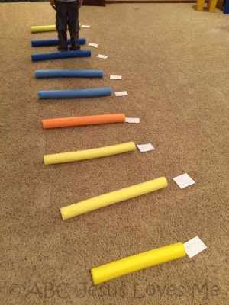 | Play dough recipe  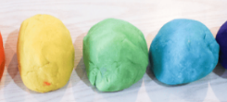  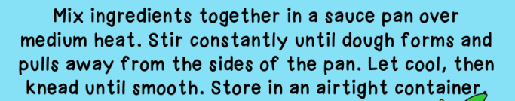  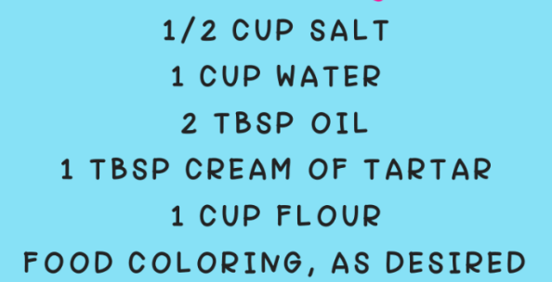

My home puzzles: “Outside my Home”

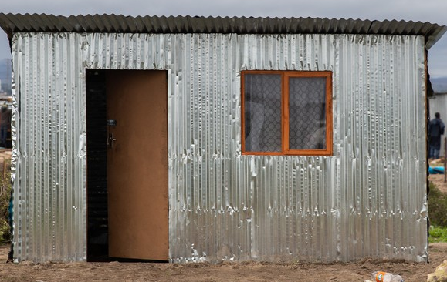

My home puzzles: “Outside my Home”

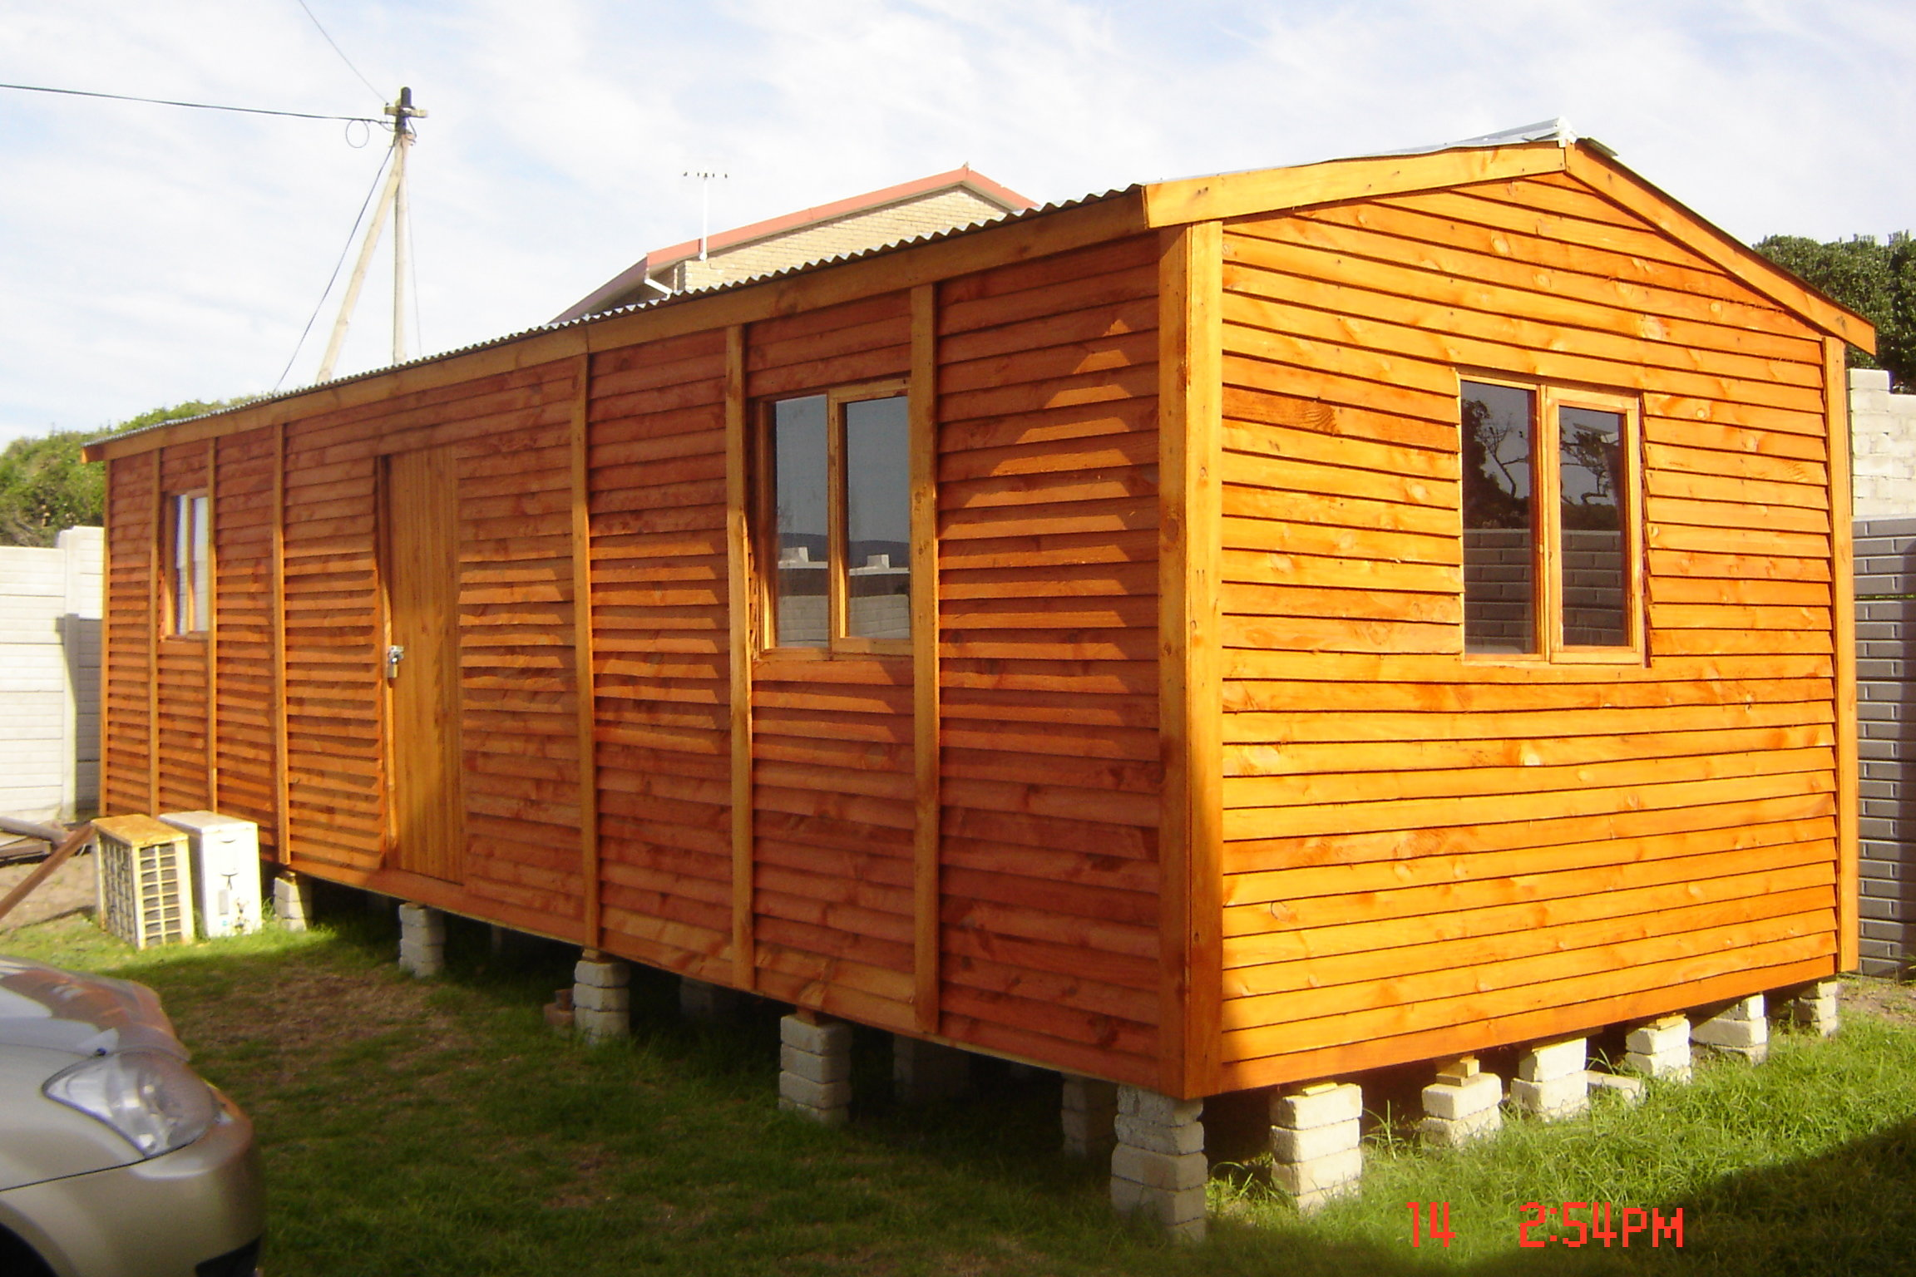

My home puzzles: “Outside my Home”

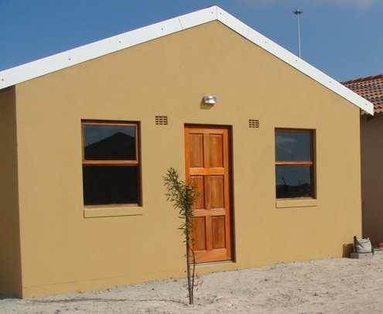

CSPID RURAL WESKUS SPAN

My home puzzles: “Inside my Home”

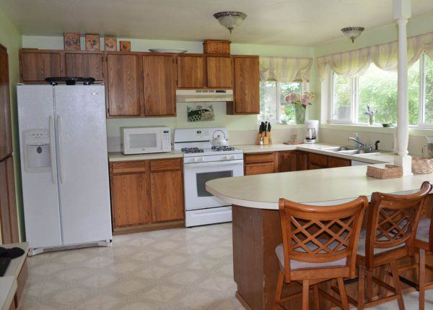

My home puzzles: “Inside my Home”
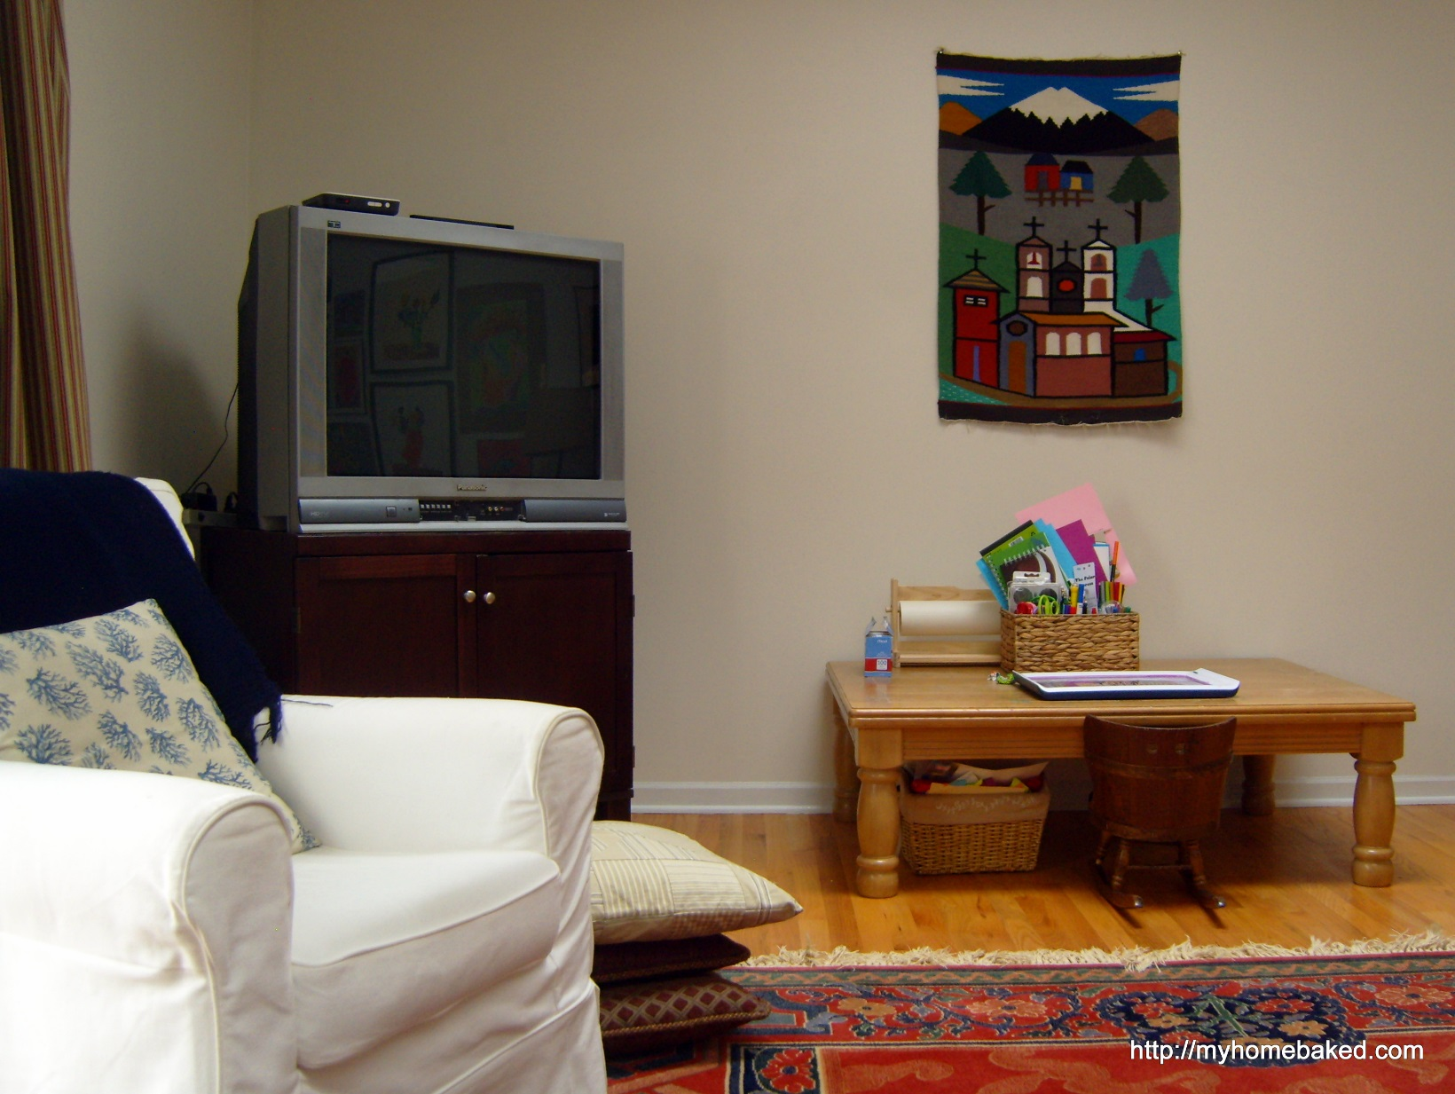

My home puzzles: “Inside my Home”
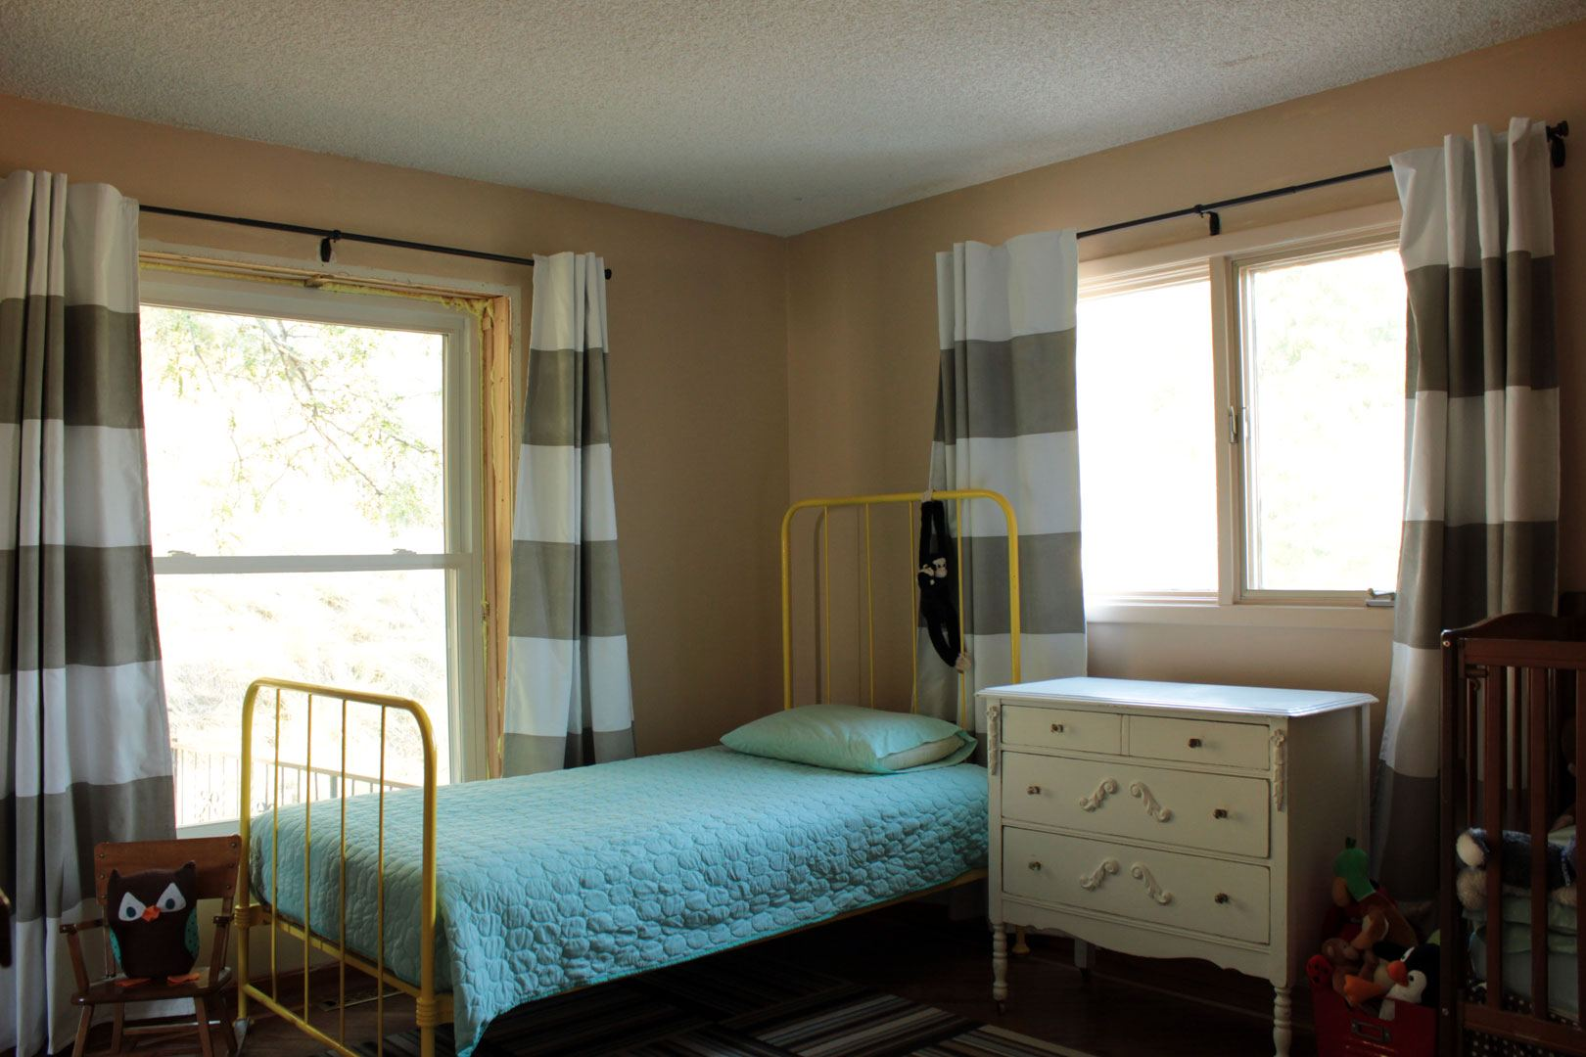

My home puzzles: “Inside my Home”
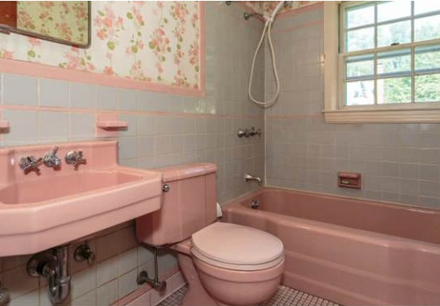

“Let’s build a home” play dough activity sheet:
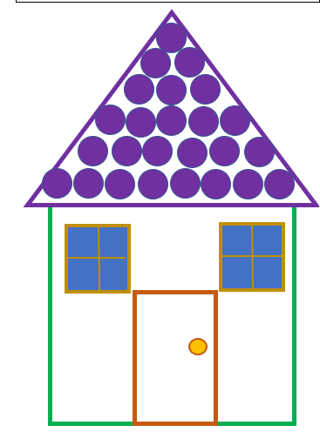
Transitional & Interactive groups

QUALITY ASSURED AND APPROVED BY:
MR EJ NGCOBO
DIRECTOR: INCLUSIVE EDUCATION
SIGNATURE:
DATE:

